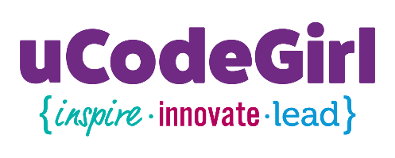

Parent's or Guardian's Participation Agreement of
Waiver of Liability, Indemnification, and Medical Release

To be signed by parent/guardian if the participant is under 18 years of age.
Acknowledgement and Assumption of Risk
The undersigned parent and/or legal guardian does hereby acknowledge that he/she is aware of the dangers and the risks to the participant's person and property involved in participating in: uCodeGirl Crack the Code: Summer Technology Camp for Girls
The undersigned parent and/or legal guardian and participant understand that this activity involves certain risks for physical injury to the participant. We also understand there there are potential risks of which may presently be unknown. Because of the dangers of participating in this activity, the undersigned parent and/or legal guardian and participant recognize the importance and the participant agrees to fully comply with the applicable laws, policies, rules and regulations, and any supervisors's instructions regarding participation in this activity The undersigned parent and/or legal guardian and participant understand that the State of North Dakota (State) does not insure participants in the above-described activity, that any coverage would be through personal insurance, and the State has no responsibility or liability for injury resulting from this activity.
The undersigned parent and/or legal guardian acknowledges that the participant voluntarily elects to participate in this activity with knowledge of the danger involved, and hereby agrees to accept and assume any and all risks of property damage, personal injury, or death.
Waiver of Liability and Indemnification: In consideration for being allowed to voluntarily participate in the above-referenced event, on behalf of myself, the participant, his/her personal representatives, heirs, next of kin, successors and assigns, the undersigned parent and/or legal guardian forever:
- waives, releases, and discharges the State of North Dakota and its agencies, officers, and employees from any and all liability for the participant’s death, disability, personal injury, property damages, property theft or claims of any nature which may hereafter accrue to the participant, and the participant’s estate as a direct or indirect result of participation in the activity or event; and
- defend, indemnify, and hold harmless the State of North Dakota, its agencies, officers and employees (State), from any and all claims of any nature, including all costs, expenses, and attorney's fees, which may in any manner result from or arise out of this agreement, except for claims resulting from or arising out of the State's sole negligence.
Consent is given for the participant to receive medical treatment, which may be deemed advisable in the event of injury, accident or illness during this activity or event. This release, indemnification, and waiver shall be construed broadly to provide a release, indemnification, and waiver to the maximum extent permissible under applicable law.
I, the undersigned parent and/or legal guardian, affirm that I am freely signing this agreement. I have read this form and fully understand that by signing this form I am giving up legal rights and/or remedies which may otherwise be available to myself, the minor participant regarding any losses the participant may sustain as a result of participation in the activity. I agree that if any portion is held invalid, the remainder will continue in full legal force and effect.
Read Before Signing
Name of Minor: _________________________________________________
Age of a Minor: __________________________________________________
Name of Parent/Guardian: _________________________________________
Signature of Parent/Guardian: ______________________________________
Date: __________________________________________________________

